**Diversity in Living Organisms**

* The variety in living organisms existing on the Earth is called **biodiversity**.
* **Taxonomy** is a biological science which deals with the identification, nomenclature and classification of organisms.
* The system of sorting living organisms into various groups based on their characteristic similarities and differences is called **classification**.
* The principles of classification help us in tracing the evolutionary relationships of the species around us.
* Organisms with ancient body designs are referred to as **primitive** or lower organisms, while organisms which have acquired their body designs relatively recently are called **advanced** or higher organisms.
* A **species** is a group of organisms of a particular kind whose members can interbreed among themselves to produce fertile young ones.

# Binomial Nomenclature

* The **binomial nomenclature** system was suggested by the Swedish botanist **Carolus Linnaeus**.
* According to binomial nomenclature, every organism is given a scientific name for identity. The scientific name includes two terms. The **first term** is the name of the **genus**, and the **second term** is the name of the **species**.

# Hierarchy of Classification

Kingdom  Phylum  Class  Order  Family  Genus  Species

**Five Kingdom Classification**

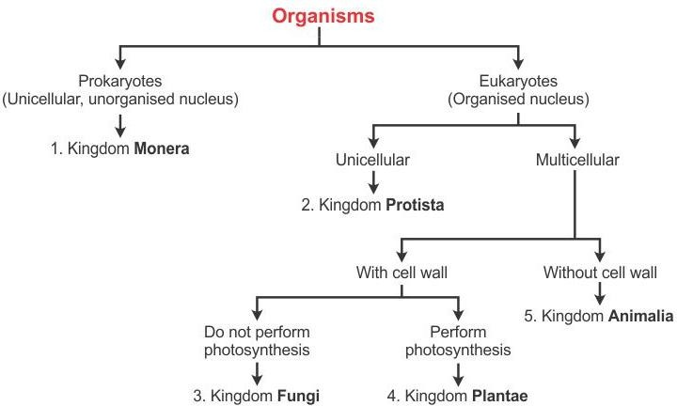

|  |  |  |
| --- | --- | --- |
| **KINGDOM** | **CHARACTERISTICS** | **EXAMPLES** |
| Monera | * Organisms have a prokaryotic cell structure. * The cell lacks a distinct nucleus. | Bacteria, *Cyanobacteria*, *Mycoplasma* |
| Protista | * Contain a well-defined nucleus. * Nuclear materials are organised in the form of a linear, double-stranded and helical DNA along   with proteins. | *Chlamydomonas*, *Euglena*, *Amoeba* |
| Fungi | * Possess a true nucleus and a definite cell wall,   which is composed of chitin. | *Mucor*, *Rhizopus*, *Puccinia* |
| Plantae | * Cell is bound by a cell wall, which is made of cellulose. * Contains a true nucleus and membrane-bound   cell organelles. | Algae, mosses, ferns |
| Animalia | * Lack cell wall and plastid. | Earthworm, *Sycon*, beetle |

**Classification of Kingdom Plantae**

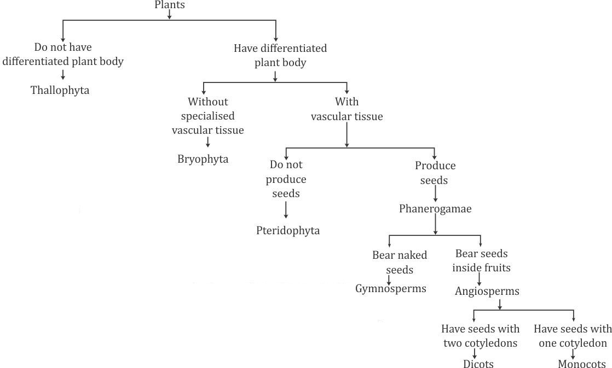

|  |  |  |
| --- | --- | --- |
| **SUBKINGDOM–DIVISION** | **CHARACTERISTICS** | **EXAMPLES** |
| Subkingdom Cryptogamae Division Thallophyta/Algae | * Plants have an irregularly shaped, undifferentiated body called thallus. * Predominantly aquatic. | *Nostoc, Oscillatoria, Chlamydomonas* |
| Subkingdom Cryptogamae Division Bryophyta | * Plant body is either in the form of an undifferentiated thallus or in the form of leafy erect structures**.** * No specialised tissue for the conduction   of water and other substances from one part of the plant body to another. | *Riccia, Funaria, Anthoceros* |
| Subkingdom Cryptogamae Division Pteridophyta | * Plant body is differentiated into stem, leaves and roots. * Have specialised tissue for the conduction of water and other substances from one part of the plant   body to another. | *Psilotum, Nephrolepis, Equisetum* |
| Subkingdom Phanerogamae Division Gymnospermae | * Bear naked seeds. * Usually perennial, evergreen and woody. | *Gingko, Pinus, Gnetum* |
| Subkingdom Phanerogamae Division Angiospermae | * Plant body produces seeds which are enclosed within the fruits**.** * Based on the number of cotyledons,   angiosperms are divided into two classes—monocots and dicots. | Maize, bean, wheat |

**Classification of Kingdom Animalia**

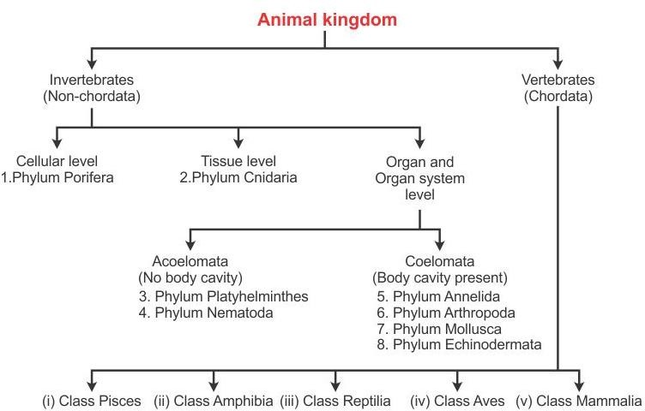

## Classification of Phylum Invertebrate

|  |  |  |
| --- | --- | --- |
| **PHYLUM** | **CHARACTERISTICS** | **EXAMPLES** |
| Porifera | * Simplest multicellular animals with perforated bodies. * The body consists of a tube. | *Sycon*, bath |
| Coelenterata | * Have a two-layered body wall, which encloses a single cavity in which digestion takes place. * There are finger-like projections called tentacles   present near the mouth for catching food. | *Hydra*, jellyfish |
| Platyhelminthes | * Small, soft, flattened and unsegmented worms. * Do not have a body cavity or a coelom. | Liver fluke, tapeworm |
| Annelida | * The body is cylindrical and divided into ring-like segments. * Have a true body cavity called coelom, present between the body wall and the digestive tube,   which is filled with coelomic fluid. | Earthworm, leech |
| Nemathelminthes | * The body is long, cylindrical and unsegmented without a body cavity. * The nervous system is well-developed and   consists of simple nerves. | Hookworm,  *Ascaris* |
| Arthropoda | * Have jointed limbs, one pair each on some or on all body segments. * Have an exoskeleton made of chitin but lack   cilia. | Crayfish, crab |
| Mollusca | * Have a soft, unsegmented body without   appendages but with a hard and calcareous shell to protect the soft body. | Snail, slug |
| Echinodermata | * The body may be spherical, cylindrical or star- shaped, hard, unsegmented or non-metameric. * Possess a spiny exoskeleton. | Starfish, brittle star |
| Urochordata | * Triploblastic animals with a coelom which show bilateral symmetry. * The body has three distinct parts—proboscis, collar and trunk. | *Balanoglossus, Amphioxus* |

**Classification of Phylum Vertebrata**

|  |  |  |
| --- | --- | --- |
| **CLASS** | **CHARACTERISTICS** | **EXAMPLES** |
| Pisces | * Organisms belonging to Class Pisces are fish. * They are cold-blooded or poikilothermic animals. | Shark, dogfish |
| Amphibia | * The body is divisible into a head and trunk. Neck is absent. * Have a three-chambered heart with two auricles and one ventricle. * They are cold-blooded animals. | Frog, toad |
| Reptilia | * The body is divisible into head, neck, abdomen and tail. * Most of them have a three-chambered heart.   Ventricle of the heart is partially divided. | Lizard, snake |
| Aves | * All birds belong to Class Aves. * Warm-blooded or homeothermic animals. * Heart is four-chambered. | Pigeon, sparrow |
| Mammalia | * Warm-blooded animals. * Have a four-chambered heart with two auricles and two ventricles. | Cat, dog |

**Differences between Vertebrates and Invertebrates**

|  |  |
| --- | --- |
| **VERTEBRATES** | **INVERTEBRATES** |
| 1. Have an internal skeleton | 1. No internal skeleton |
| 2. Backbone present | 2. Backbone absent |
| 3. Tail usually present | 3. Tail absent (anus at the tip of the back end of the body) |
| 4. Heart on the ventral side of the body | 4. Heart, when present, on the dorsal  side of the body |
| 5. Nerve (spinal) cord dorsal and hollow | 5. Nerve cord ventral and solid |
| 6. Have two pairs of limbs | 6. Have three or more pairs of limbs if present |
| 7. Haemoglobin in red blood cells | 7. Haemoglobin, if present, dissolved |
| 8. Examples: Fish, frog, lizard, bird | 8. Examples: Leech, earthworm, *Sycon* |